Description of clothing items

Women’s
1.Winter Arc- The Midnight Sin jacket
The Midnight Sin Winter Jacket is crafted in exquisite high-grade faux leather and enveloped in indulgent sherpa fur, offering a harmony of warmth and refinement. Its sculpted silhouette, polished detailing, and midnight finish evokes quiet luxury. An intimate fusion of comfort and sophistication; it elevates winter dressing to an art form.
Materials
Faux leather
Sherpa fur

Composition
- Italian 302 faux leather (outer shell)
- Tibetan sherpa fabric (inner lining)
Care
- Dry clean only
- Do not machine wash or tumble dry
- Wipe faux leather with a damp soft cloth
- Store away from direct sunlight to preserve finish
- Store in a cool and dry place
Origin
- Designed in India
- Ethically crafted in limited quantities

Model info:
Model is wearing size ‘S’
Model height: 171cm/ 5’7

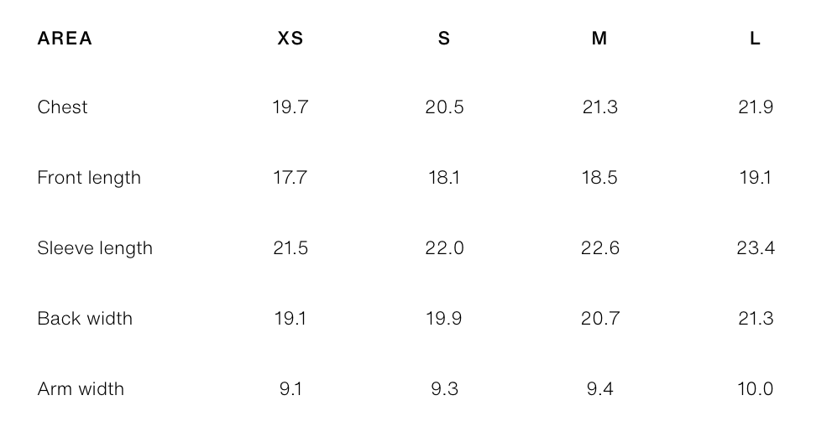
The jacket will only have 3 sizes small, medium and large

2.Winter Arc- The Outlaw Crew varsity jacket
The Outlaw Crew Varsity Jacket merges elevated street style with meticulous craftsmanship. Premium cotton twill, a warm polyfil layer, and a refined taffeta lining ensure comfort and structure. With its curated patches and bold graphic accents, it embodies modern rebellion. A statement piece that embodies artistry, warmth, and cultured street luxury.
Materials
Cotton twill 500 gsm
Monolith silk taffeta
sheep wool threaded poyfil
Composition
- double threaded cotton twill (outer)
- Oxford sheep wool polyfil (insulation)
- Monolith silk taffeta (inner lining)
Care
- Dry clean only
- Do not machine wash or tumble dry
- Store away from direct sunlight to preserve finish of prints
- Store in a clean and dry place
Origin
- Designed in India
- Ethically crafted in limited quantities
Model info:
Model is wearing size ‘S’
Model height: 171cm/ 5’7

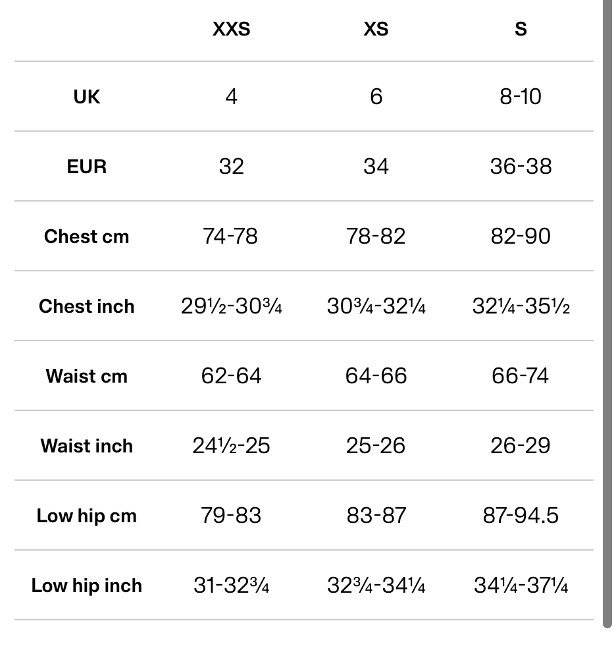
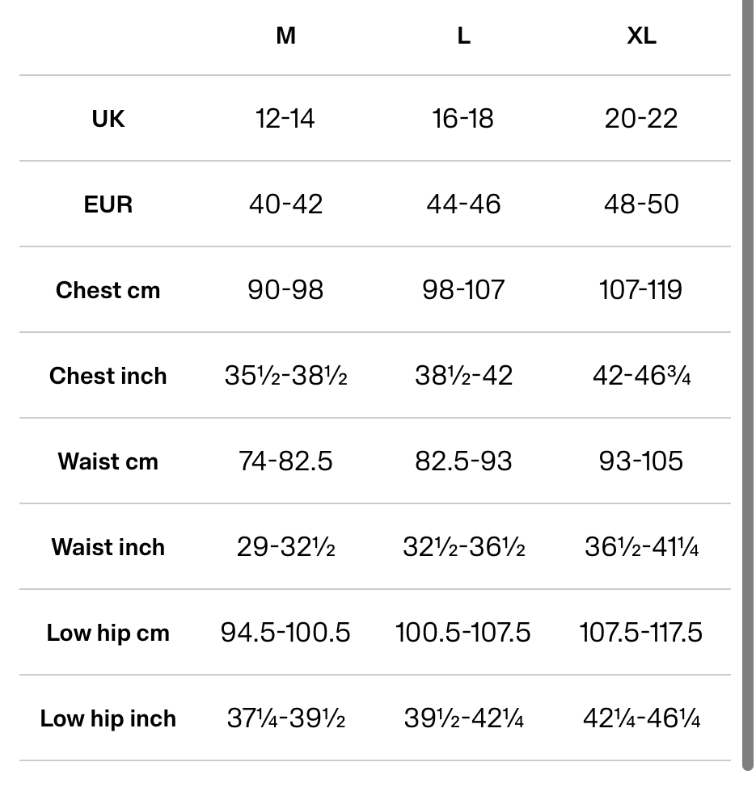

3.Winter Arc- shadow of louve sweatpants
The Shadow of Louve Sweatpants reinterprets casual wear through a refined blend of sleek faux leather and tailored cotton twill. With a sculpted fit and a soft, elevated finish, they embody understated opulence. Versatile and effortlessly polished, they bring contemporary luxury to everyday movement and modern street sophistication.
Materials
Cotton twill
Faux leather
Composition
- Cotton twill
- Faux leather paneling
Care
- Hand wash inside-out in cold water
- Do not wring; air dry only
- Avoid ironing directly on faux leather
- Do not bleach
Origin
- Designed in India
- Ethically crafted in limited quantities

Model info:
Model is wearing size ‘S’
Model height: 171cm/ 5’7

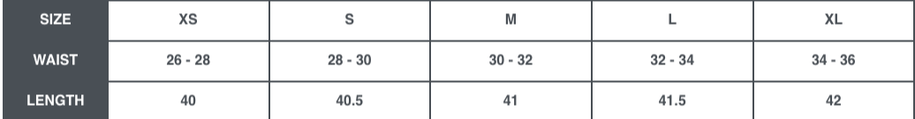In the women’s section this product will only have s, m, l and xl

4.Winter Arc- lace & roses tank top
The Laces & Roses Tank Top pairs a beautifully sculpted white silhouette with delicate red lace tracing the neckline. Crafted from a soft, form-flattering fabric and trimmed with whisper-light lace, it blends grace and allure effortlessly. Feminine, refined, and timeless; an intimate expression of modern romantic luxury.
Materials
Lycra lace
300 gsm 4-way cotton lycra
Composition
- 300 GSM premium hosiery
- Lycra lace detailing (neckline)
Care
- Hand wash in cold water
- Do not stretch lace while wet
- Lay flat to dry
- Iron on low heat; avoid lace area
Model info:
Model is wearing size ‘S’
Model height: 171cm/ 5’7


Origin
- Designed in India
- Ethically crafted in limited quantities

5.Winter Arc- the icy whisperer top
The Icy Whisper is a one-shoulder ruched top crafted from premium, ultra-soft hosiery that glides effortlessly against the skin. Its sculpted silhouette, delicate ruching, and modern asymmetry create an understated yet luxurious statement—elegant, refined, and designed to elevate every moment with quiet sophistication.
Materials
300 gsm hosiery
Composition
- 300 GSM ultra-soft hosiery
- Ruching and asymmetrical construction
Care
- Hand wash only
- Do not tumble dry
- Keep away from rough surfaces to prevent pilling
- Steam lightly if needed
Origin
- Designed in India
- Ethically crafted in limited quantities
Model info:
Model is wearing size ‘S’
Model height: 171cm/ 5’7

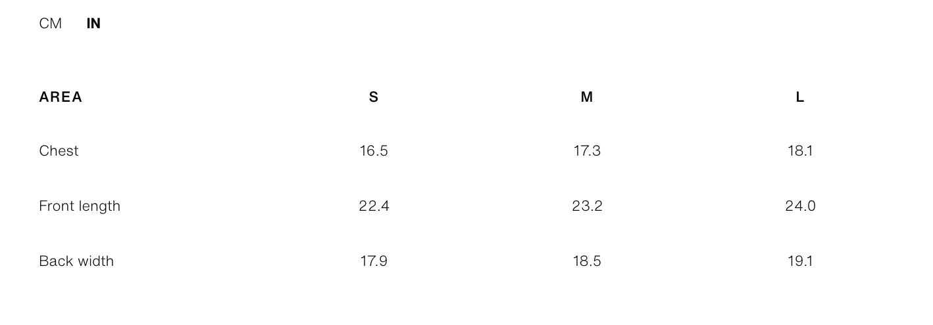
6.Winter Arc- yin yang check shirt
The Yin Yang Check Shirt reimagines classic checks with poised sophistication. Crafted from luxurious, finely woven cotton, its black-and-white palette creates a striking harmony of contrasts. The relaxed silhouette falls with effortless elegance, offering refined comfort and timeless allure.
Materials
100 % Cotton
Composition
- 100% finely woven cotton
Care
- Machine wash cold
- Do not bleach
- Iron on medium heat
- Air dry recommended to prevent shrinkage
Origin
- Designed in India
- Ethically crafted in limited quantities
Model info:
Model is wearing size ‘S’
Model height: 171cm/ 5’7

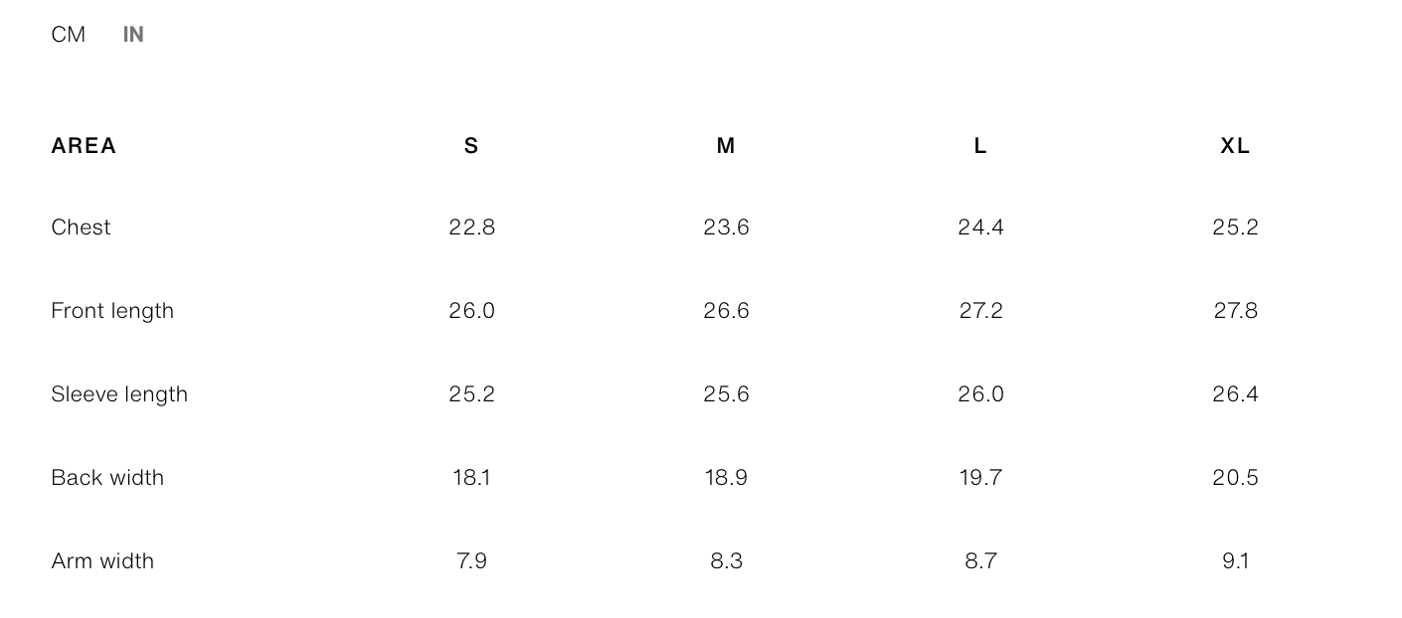
7.Winter Arc- ocean breeze blue check shirt
The Ocean Breeze Blue Check Shirt captures the calm sophistication of coastal hues. Crafted from exquisitely soft, premium cotton, its serene blue checks offer a fresh yet timeless appeal. The relaxed silhouette drapes with effortless elegance, creating a refined wardrobe staple that embodies ease, balance, and elevated everyday style.
Materials
100% cotton
Composition
- 100% premium cotton
Care
- Machine wash with similar colours
- Use mild detergent
- Iron on medium heat for crisp finish
- Do not tumble dry for longevity
Origin
- Designed in India
- Ethically crafted in limited quantities
Model info:
Model is wearing size ‘S’
Model height: 171cm/ 5’7

MEN’S

1.Winter Arc- haw eye grey vest
The Hawk Eye Grey Vest is crafted from exceptionally soft, resilient French terry, designed for a fluid, drop-shoulder drape. Its commanding eagle motif contrasts elegantly with the subtly distressed waist hem, creating a curated edge. Effortlessly modern and artfully textured, it embodies contemporary street luxury with a bold yet understated aesthetic.
Materials
French terry

Composition
- 100% French terry cotton
- Printed eagle motif
- Subtly distressed hem finish
Care
- Gentle machine wash in cold water
- Wash inside-out
- Do not tumble dry
- Iron on low heat (avoid print)
origin
- Designed in India
- Ethically crafted in limited quantities

Model info:
Model is wearing size ‘M’
Model height: 175cm/ 5’9

2.Winter Arc- ocean breeze blue check shirt
The Ocean Breeze Blue Check Shirt captures the calm sophistication of coastal hues. Crafted from exquisitely soft, premium cotton, its serene blue checks offer a fresh yet timeless appeal. The relaxed silhouette drapes with effortless elegance, creating a refined wardrobe staple that embodies ease, balance, and elevated everyday style.
Materials
100% cotton
Composition
- 100% premium cotton
Care
- Machine wash with similar colours
- Use mild detergent
- Iron on medium heat for crisp finish
- Do not tumble dry for longevity
Origin
- Designed in India
- Ethically crafted in limited quantities
Model info:
Model is wearing size ‘M’
Model height: 175cm/ 5’9

3.Winter Arc- yin yang check shirt
The Yin Yang Check Shirt reimagines classic checks with poised sophistication. Crafted from luxurious, finely woven cotton, its black-and-white palette creates a striking harmony of contrasts. The relaxed silhouette falls with effortless elegance, offering refined comfort and timeless allure.
Materials
Oxford gittisham 100% cotton

Composition
- 100% premium cotton
Care
- Machine wash with similar colours
- Use mild detergent
- Iron on medium heat for crisp finish
- Do not tumble dry for longevity
Origin
- Designed in India
- Ethically crafted in limited quantities
Model info:
Model is wearing size ‘M’
Model height: 175cm/ 5’9

4.Winter Arc- shadow of louve sweat pants
The Shadow of Louve Sweatpants reinterprets casual wear through a refined blend of sleek faux leather and tailored cotton twill. With a sculpted fit and a soft, elevated finish, they embody understated opulence. Versatile and effortlessly polished, they bring contemporary luxury to everyday movement and modern street sophistication.
Materials
Cotton twill
Faux leather
Composition
- Cotton twill
- Faux leather paneling
Care
- Hand wash inside-out in cold water
- Do not wring; air dry only
- Avoid ironing directly on faux leather
- Do not bleach
Origin
- Designed in India
- Ethically crafted in limited quantities
Model info:
Model is wearing size ‘M’
Model height: 175cm/ 5’9

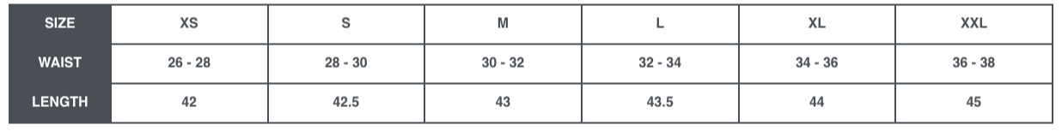

5.Winter Arc- The Outlaw Crew varsity jacket
The Outlaw Crew Varsity Jacket merges elevated street style with meticulous craftsmanship. Premium cotton twill, a warm polyfil layer, and a refined taffeta lining ensure comfort and structure. With its curated patches and bold graphic accents, it embodies modern rebellion. A statement piece that embodies artistry, warmth, and cultured street luxury.
Materials
Cotton twill __ gsm
High quality taffeta
100 gsm silkenised poyfil
Composition
- Premium cotton twill (outer)
- 100 GSM silkenised polyfil (insulation)
- High-quality taffeta (inner lining)
Care
- Dry clean only
- Do not machine wash or tumble dry
- Store away from direct sunlight to preserve finish of prints
- Store in a clean and dry place
Origin
- Designed in India
- Ethically crafted in limited quantities
Model info:
Model is wearing size ‘M’
Model height: 175cm/ 5’9

